[1] CSA-1557 CLOUD COMPUTING LAB PRACTICALS

4.Create a Snapshot of a VM and Test it by loading the Previous Version/Cloned VM.

Step-1:

First install VMware workstation on your pc/laptop. Then open the VM software and click create a new virtual machine displayed on a home tab.

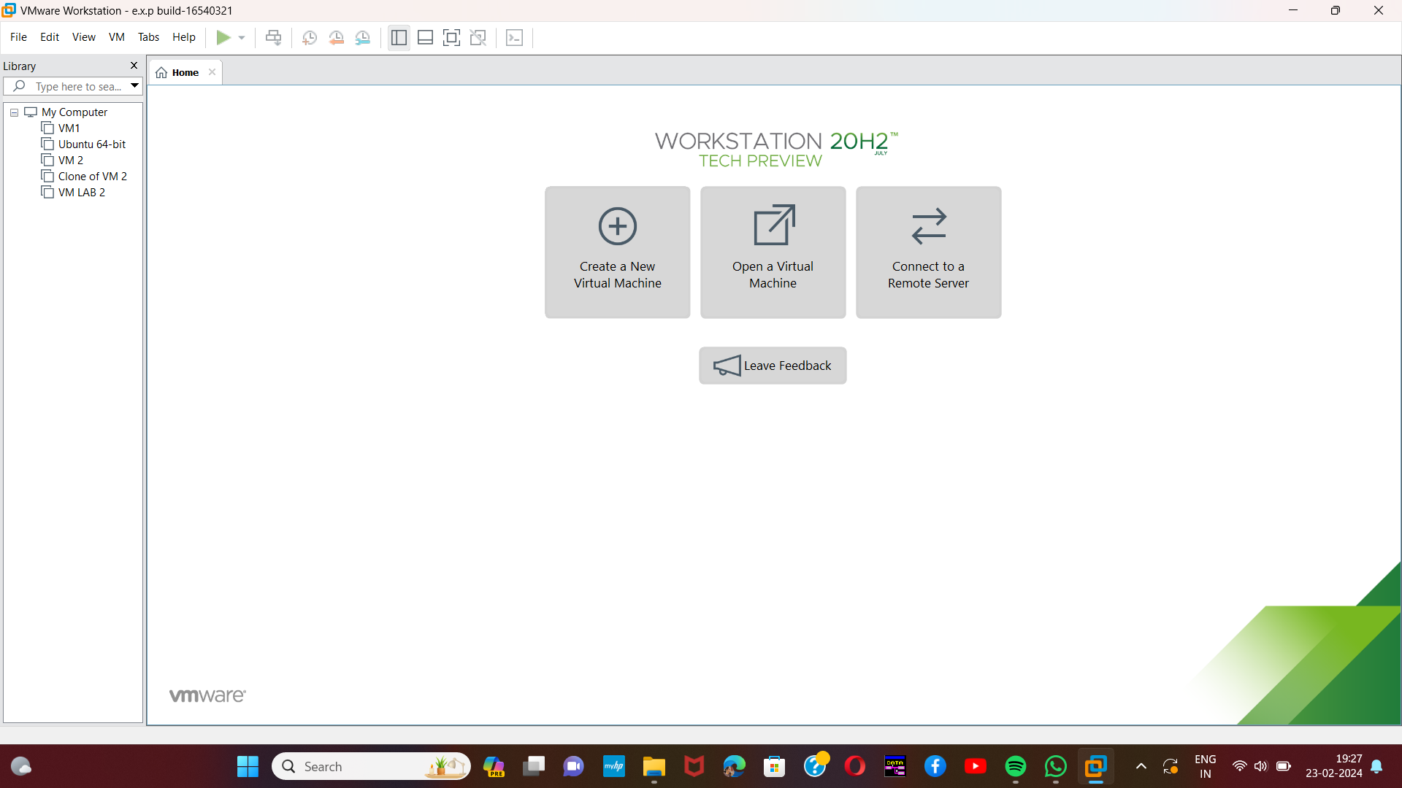

Step-2:

Then open any of the created VM.then from taskbar ,in VM option select snapshot option.

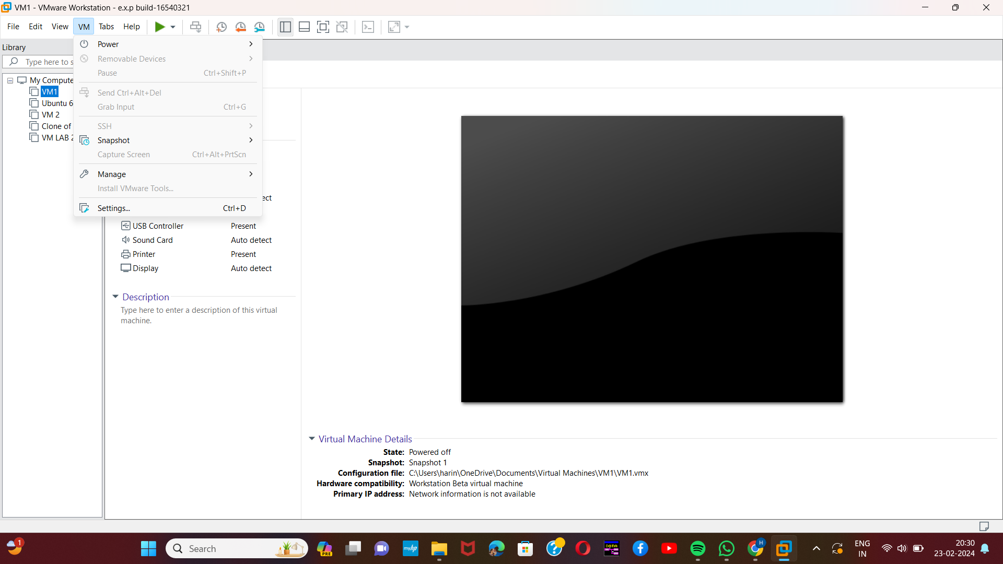[2]

Step-3:

Then take a snapshot.

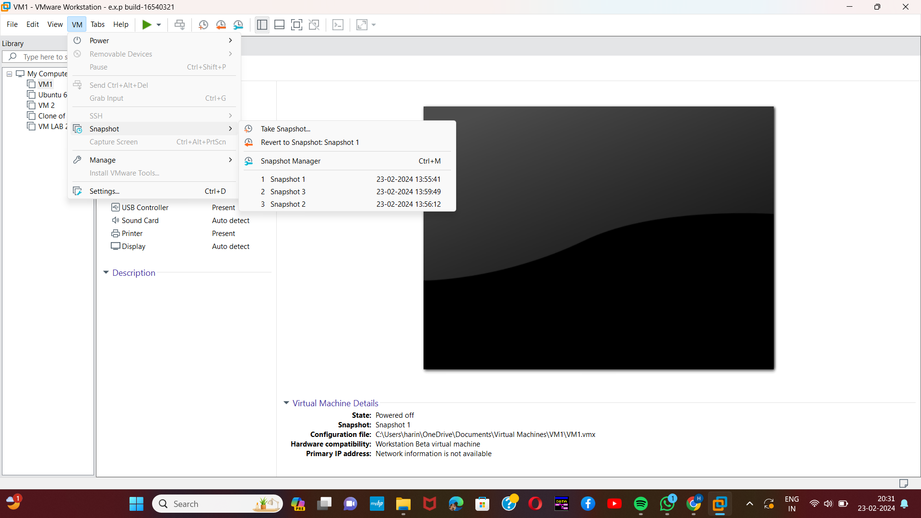

[3]Step-4:

Here,we can name the snapshot as we like.

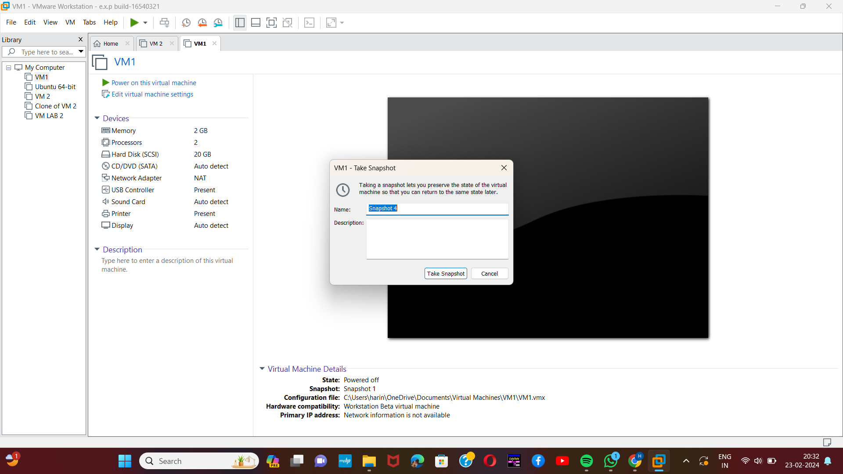

Step-5:

Then change any of the given specifications and take another snapshot of the changes.

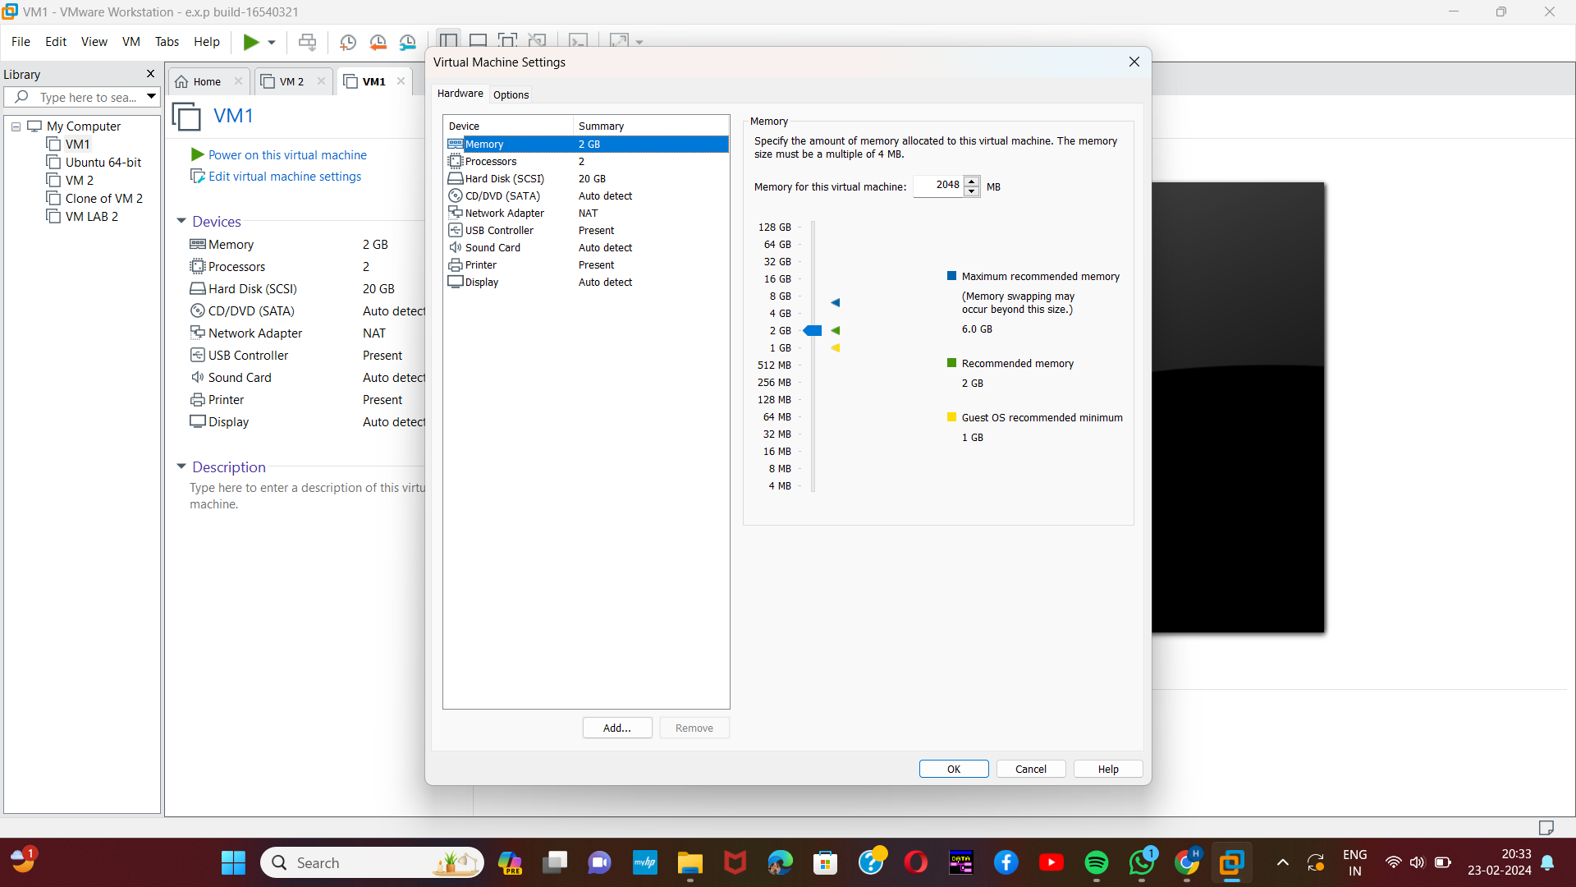

[4]Step-6:

Then again change any of the specifications and take another snapshot.

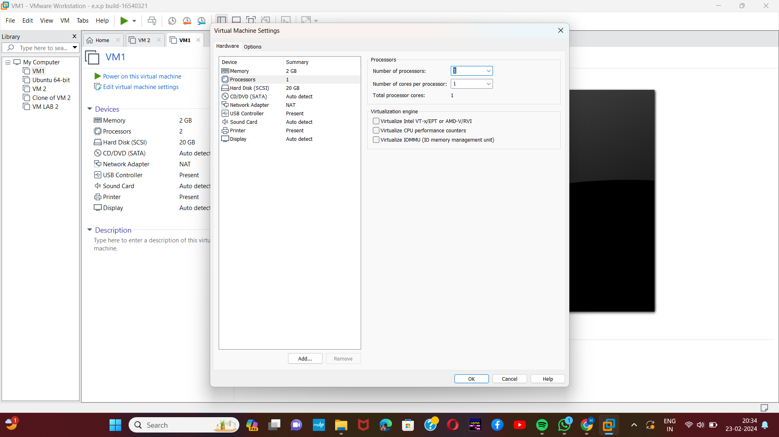

Step-7:

Then in the snapshot option select the snapshot manager option.

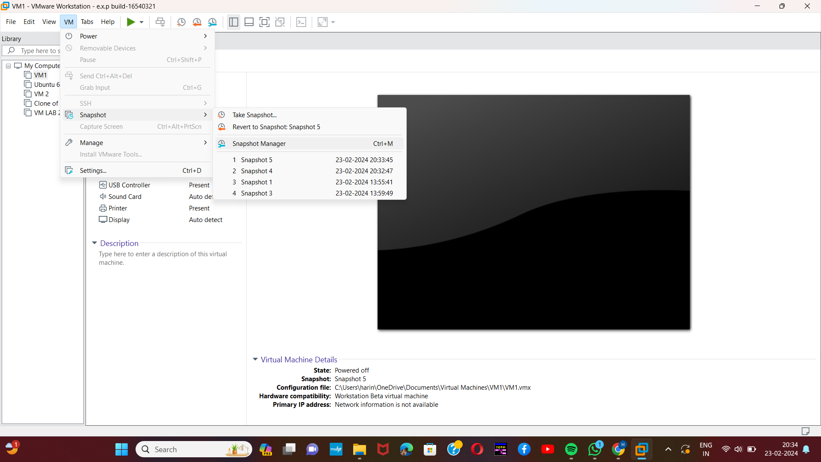

[5]Step-8:

Number of snapshot taken will be displayed. We can select any of those snapshot to go back to that specific specification. So select any of the snapshot and click yes.

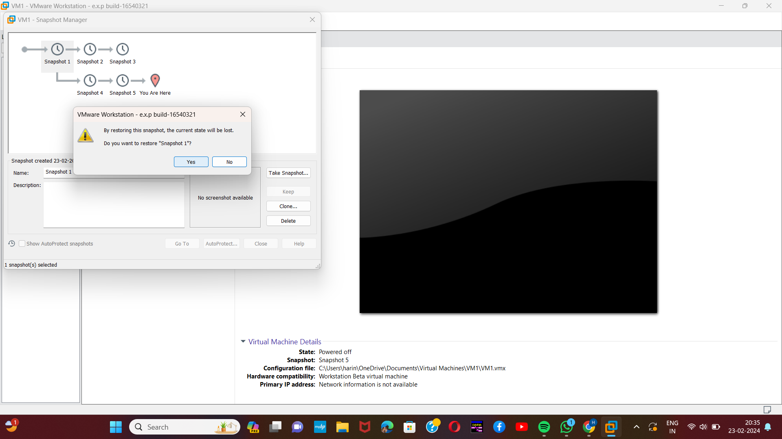

Step-9:

Our VM will be displayed on the particular snapshot.

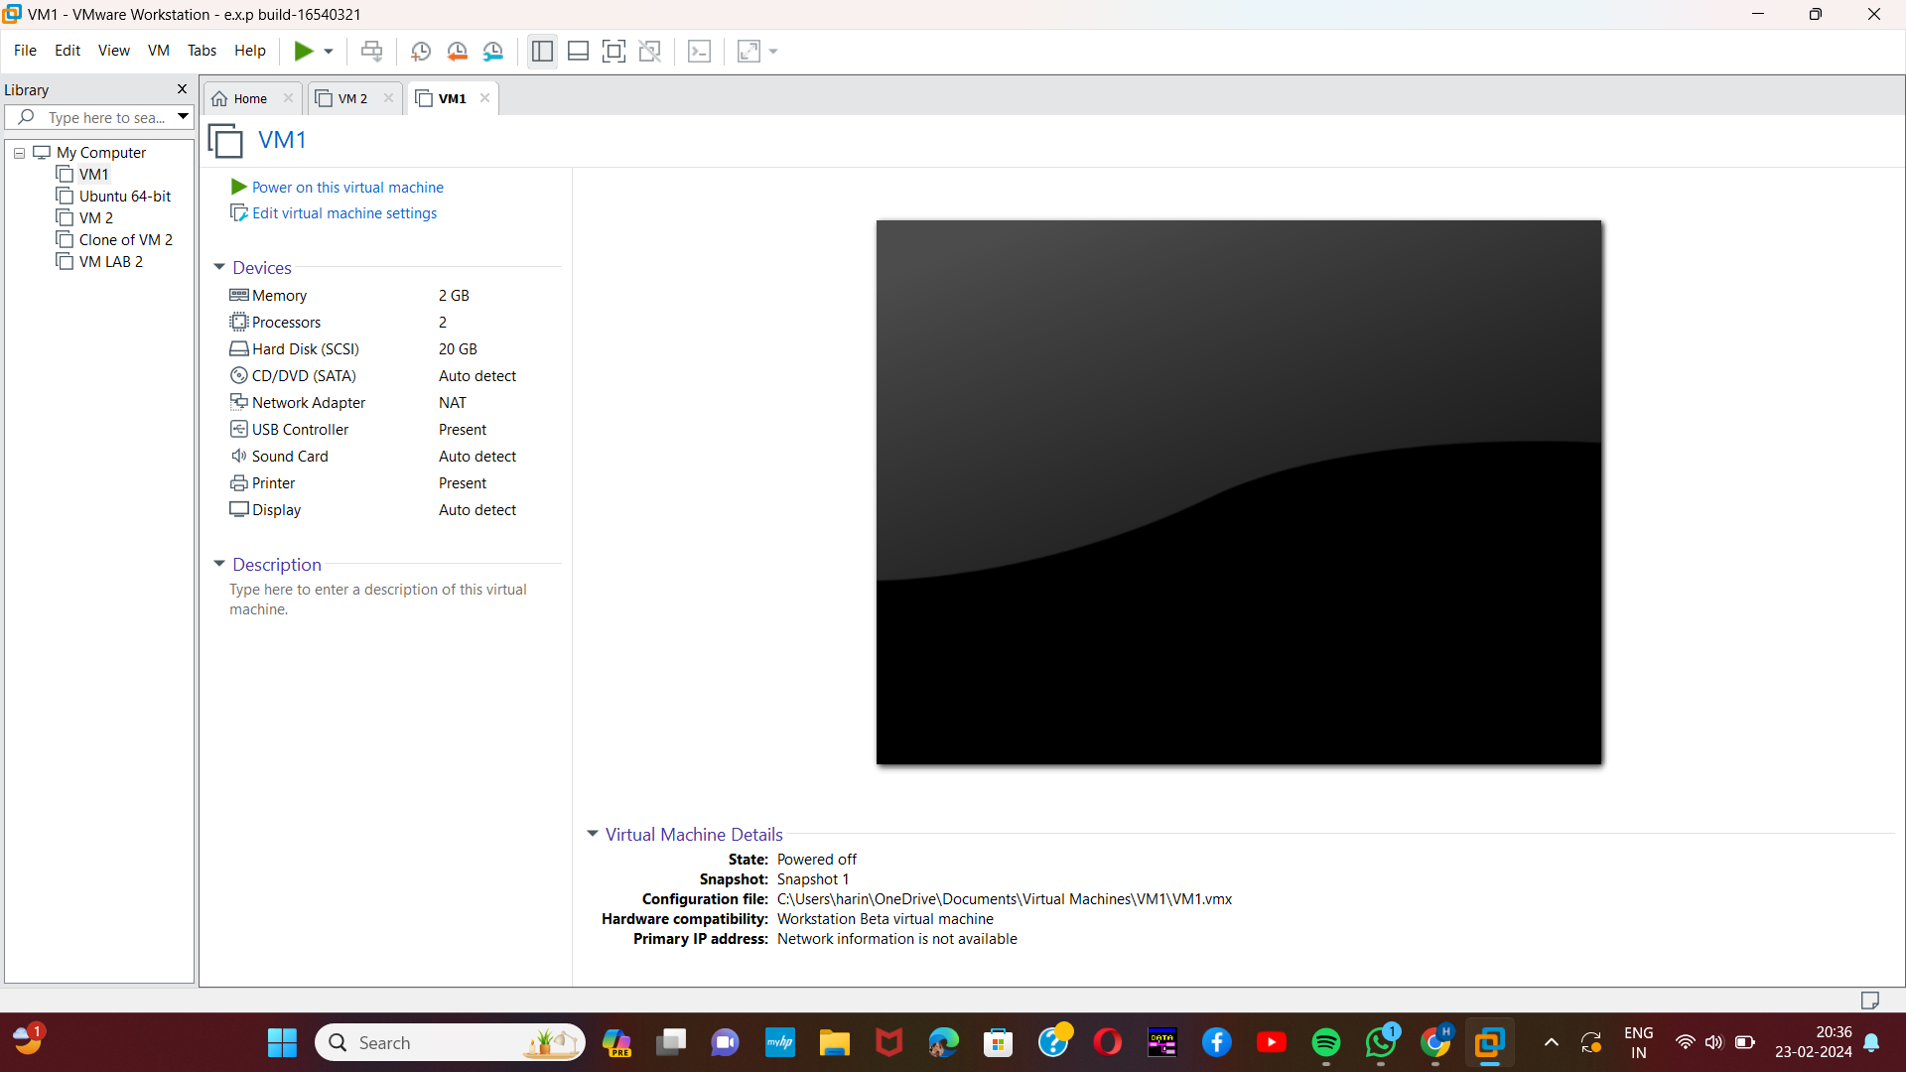

1. Harini 192221109
2. Harini 192221109
3. Harini 192221109
4. Harini 192221109
5. Harini 192221109